**Title: The Future of Tightening: AMT's Next-Gen Controllers and Customer Benefits**  
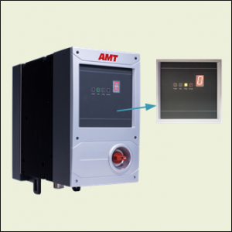

Welcome to the new era of tightening solutions from AMT. Our [latest generation of controllers](https://absgroup.in/products-category/controller), represented by the SMX series, is designed to revolutionize your tightening processes. In this article, we'll explore the customer-centric benefits and cutting-edge features that make these [controllers](https://absgroup.in/products-category/controller) a game-changer in the industry.

**SMX Series Controllers Overview:**

1. **SMX-C:**

- 7 Seg. Display

- 4 status LEDs

- Torque Controller

- Webserver

2. **SMX100:**

- 7 Seg. Display

- 4 status LEDs

- Torque Controller

- Webserver

3. **SMX300:**

- 6.5“ Display

- Torque Controller

- PC

- Webserver

4. **SMX400:**

- 10“ Display

- Torque Controller

- PC

- Webserver

**Advantages of the Integrated Webserver:**

- Enables communication with mobile devices.

- Parameterization, production screen, and diagnostic analysis via a web browser.

- No additional parameterization software necessary, eliminating software version conflicts.

**User-Friendly Operation:**

- Tools for Parameterization:

- Library Function.

- Programming Assistant.

- Graphical Programming.

- User-friendly service support.

**Easy Programming, Efficient Fault Diagnosis, High Availability:**

- Remote Accessibility: Perform actions from any location and at any time.

- Email Notifications: Maintenance personnel receive fault notifications via email.

- QR Code Innovation: Scan the QR code for automatic connection to the controller.

- Fast Parameter Changes: Maintenance technicians can swiftly adjust crucial parameters.

**Cost-Efficient Operation:**

- Minimum Training Time and Costs: The intuitive interface reduces the learning curve.

- Reduced Energy Costs: Optimize energy consumption for tightened operations.

**Conclusion:**

AMT's new tightening generation, featuring the [SMX series controllers](https://absgroup.in/products-category/controller), is not just a technological leap but a customer-centric solution. From user-friendly interfaces to remote accessibility and cost-efficient operation, these controllers redefine how tightening processes are managed. Embrace the future with AMT, where innovation meets practicality, and your benefits are at the forefront of our design philosophy.